Calibration Key Development for Fertilizer Spreader

Project Overview
Development of a calibration key for a fertilizer spreader to verify the correct opening position of the fertilizer shut-off mechanism across the specified 1–25 application scale.
Objective
To develop a simple and reliable calibration tool that can:
- Verify the shut-off plate/gate opening position.
- Ensure accurate scale-to-opening correlation.
- Improve consistency during assembly and quality inspection.
- Reduce calibration errors during production and testing.
Problem Statement
During evaluation of the spreader manual, the calibration procedure did not clearly define how the 1–25 scale positions should be checked using the calibration key. A dedicated calibration method and tool were therefore required to establish a repeatable inspection process.
Design & Development Approach
- Reviewed the spreader shut-off mechanism and scale arrangement.
- Studied the required calibration positions.
- Defined the calibration key interface and critical dimensions.
- Developed the 3D CAD model and 2D manufacturing drawing.
- Checked the key with the shut-off mechanism for proper fitment.
- Planned validation across the required scale positions.
- Documented the calibration procedure for production/quality inspection.

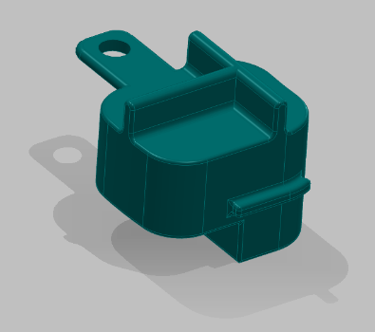 | 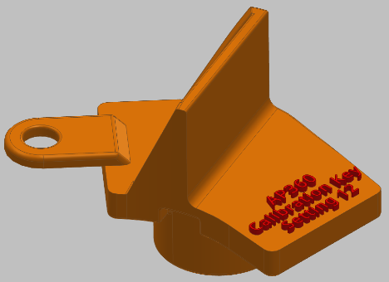 | 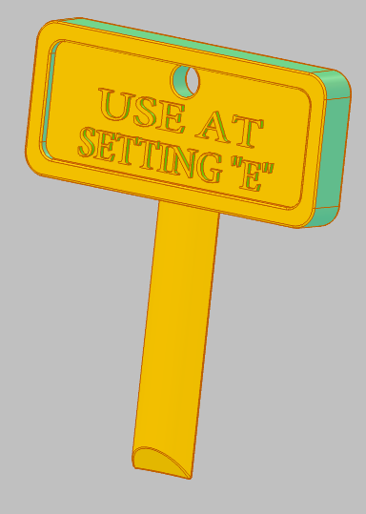

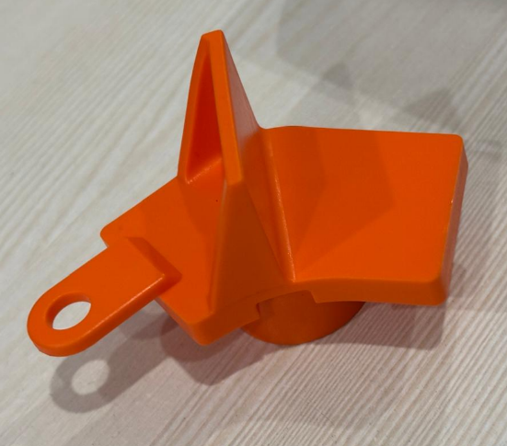 | 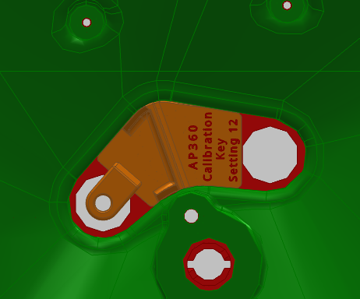

Key Design Considerations
- Correct fitment with the shut-off mechanism.
- Repeatable positioning.
- Simple operation for operators.
- Adequate strength and durability.
- Clear identification of the calibration reference.
- Compatibility with the complete 1–25 scale range.
Outcome
The project establishes a standardized calibration method for the fertilizer spreader, helping ensure that the selected scale position corresponds correctly to the intended shut-off opening.

